Olin Fine Art Gallery
2015-16 Exhibition Schedule

Patricia Maloney: A Child's Story
Sept. 18 - Oct. 11, 2015
Opening Reception and Artist Talk: Friday, Sept. 18 from 6 to 7:30 p.m.
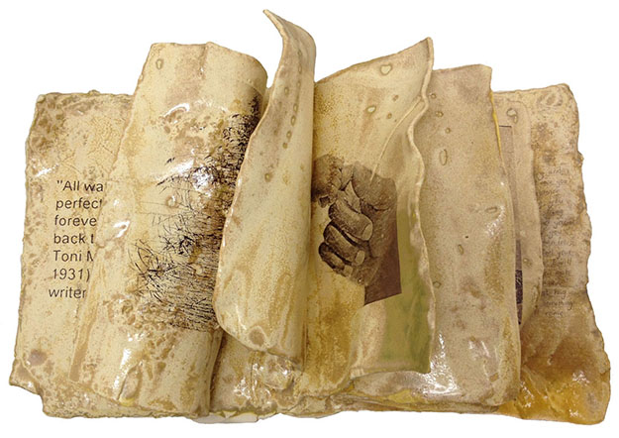
This art begs the question, “What might this child have become?” Inspired by the themes of universal loss, abandonment and vanishing childhood, Maloney’s work communicates the story of the weighted identity of the life of a child who has experienced turmoil. Missing siblings, pain, fragility and resilience are tangible in the small-scale sculptures which combine techniques of decaling, drawing, under glazing and multiple firings of images on porcelain and earthenware. Maloney’s work asks the audience to reflect on the mysteries of loss in our social context.
Patricia Maloney is Professor of Art at Washington & Jefferson College, Washington, PA. Maloney received her MFA from Oklahoma University, Norman, OK, her MA from Murray State University, Murray, KY and her BFA from Louisville School of Art, Anchorage, KY.

Dylan Collins
Oct. 30 - Dec. 6, 2015
Opening Reception and Artist Talk: Friday, Oct. 30 from 6 to 7:30 p.m.
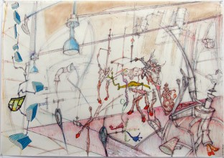
Drawing attention to the complex relationships between organic bodies and the desires of the human-made world, Dylan Collins creates work that alludes to anatomical models, exploded view drawings, food chains and similar diagrammatic systems. His drawings and sculptures are rife with cultural authority and take pleasure, at times through humor and ambiguity, in manipulating language. Collins creates anatomies that hybridize human, animal and mechanical traits, in order to locate these bodies as a site of conflict.
Dylan Collins is Assistant Professor and Sculpture Program Coordinator at West Virginia University, Morgantown, WV. Collins received his MFA from Kent State University, Kent, OH and both his MA and BA from Eastern Illinois University, Charleston, IL.

Amy Schissel
Feb. 5-28, 2016
Opening Reception and Artist Talk: Friday, Feb. 5 from 6 to 7:30 p.m.
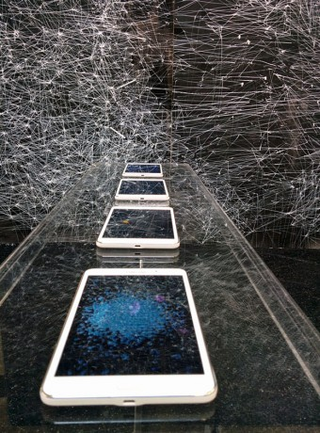
Creating large-scale works, Amy Schissel explores the mapping of new social cartographies that examine the contemporary state of painting/drawing in the age of digital image making. Schissel combines the analogue continuous nature of the painted brushstroke with algorithmic digital processes to create works that take on the look of digitized Abstract Expressionism. Her work aims to invest in the re-contextualization of painting/drawing and its function within the context of a more digitally saturated world.
Amy Schissel is Assistant Professor of Painting at West Virginia University, Morgantown, WV. Schissel received both her MFA and BFA from the University of Ottawa, Ottawa, Ontario, Canada.

Amanda McCavour
March 11 - April 3, 2016
Opening Reception and Artist Talk: Friday, March 11, 6 to 7:30 p.m.
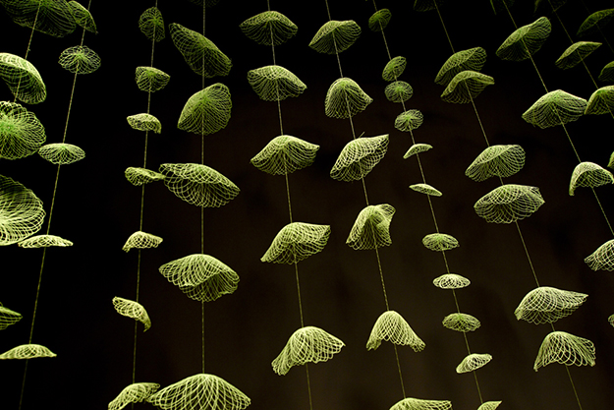
Using a sewing machine to create an accumulation of “thread drawings,” Amanda McCavour’s large-scale installations explore the concept of natural verses manufactured.
The form of McCavour’s work borrows from structures and growth patterns found in minerals and plants while their display references dioramas, props and specimen illustrations of natural history museums.
Amanda McCavour lives and works in Toronto, Canada. She received her MFA from Temple University, Philadelphia, PA and her BFA from York University, Toronto, Ontario, Canada.

W&J Senior Shows
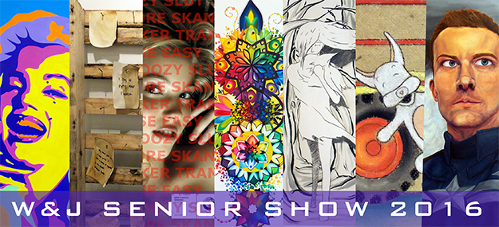
Senior Show I: April 15 - 24, 2016
Opening Reception and Artist Talks: Friday, April 15, 6 to 7:30 p.m.
Featuring: Beka Bellhy, Madison Gedman, Olivia Oddo, Jessi Price
Senior Show II: April 29 - May 8, 2016
Opening Reception and Artist Talks: Friday, April 29, 6 to 7:30 p.m.
Featuring: Stephanie Chadwick, Natalie Paul, Julie Price
Washington & Jefferson College art and art education majors graduating in spring 2016 exhibit their work across a variety of media in this annual senior capstone event.
Each exhibition features half of the graduating seniors from the class of 2016.

